Glen Elder, KS -- Heritage & History
~ Memoir Lane ~

GEHS -- H.S. Comet c.1913 Volume 1, Issue 3
-- excerpts
The material on this and related pages is taken directly from the H.S. Comet
-- The Glen Elder High School newspaper founded in 1912-1913.
Thanks to Roger Torrens, Wentzville, Missouri, for contacting me and then giving five original issues of this publication to GlenElder.com. (the issues are being given to the Glen Elder Historical Society) Over 10 years ago, Mr. Torren's mother found and purchased the copies at garage sale somewhere in Missouri. Curious as to where Glen Elder might be located, Torren's did an internet search and quickly discovered GlenElder.com and the Memoir Lane section of the website. In turn, he contacted the site developer and then personally delivered the issues to him this past summer. How the copies of this 1913 Glen Elder High School student publication made their way over 350 miles from the school into Missouri is unknown.
At some point in the near future, copies of these newspapers will be made available to the public.
The paper more closely resembles a magazine / booklet and includes heavy blue paper as a cover. The entire publication is very professionally done and well written. Besides serious stories covering students and teachers, there are also satires and stories of wit contributed by students. Each paper contains several photos; some will be able to identify parents or grandparents. Likewise, there are multiple photographs and pages of ads purchased by local businesses to cover cost. In 1913, Glen Elder students were attending the community's first school located on the hill west of town, the two-story building was constructed of native limestone, some of which, after the building was torn down in 1938, was used to build Ernie Norris' Castle Service Station.

-----------------------------------------------------------------
(The following is recopied verbatim from the paper)
The Comet is the first paper ever published by the students of the Glen Elder High School.
The plan was voted upon and a majority of the High School were in favor of trying it so an editorial staff was chosen. Each class has two representatives from it in the staff. The representatives from the Senior class are Walter German, Editor and Erba Kaull, Business manager, the Junior class by Velma Sheets and Lyle Hadley, the Sophomore class by Russell Thomasson and James Pratt and the Freshmen by Vera Lee and Elith Kaull.

Almost all the High School students and the Faculty are subscribers and a great number of the Alumni. The paper now has ______ subscribers. Since the first issue the Business Mgr. has not found it so difficult to secure subscribers and the business men have been very pleasing patrons.

The Comet goes to several parts of Kansas and into Neb.

The annual which will be the last issue of the Comet this term will be about three times the size of the regular Comet. A great number of issues of the annual was sold before it was printed.

Thanking the subscribers and business men for their patronage we will now take our leave hoping to meet you next year.

Continued on following 3 pages

This image (left) is the inside cover or title page found in every issue
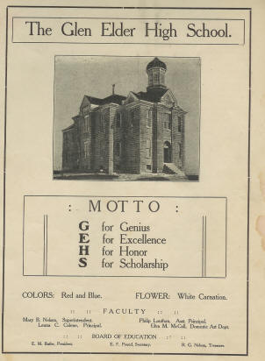

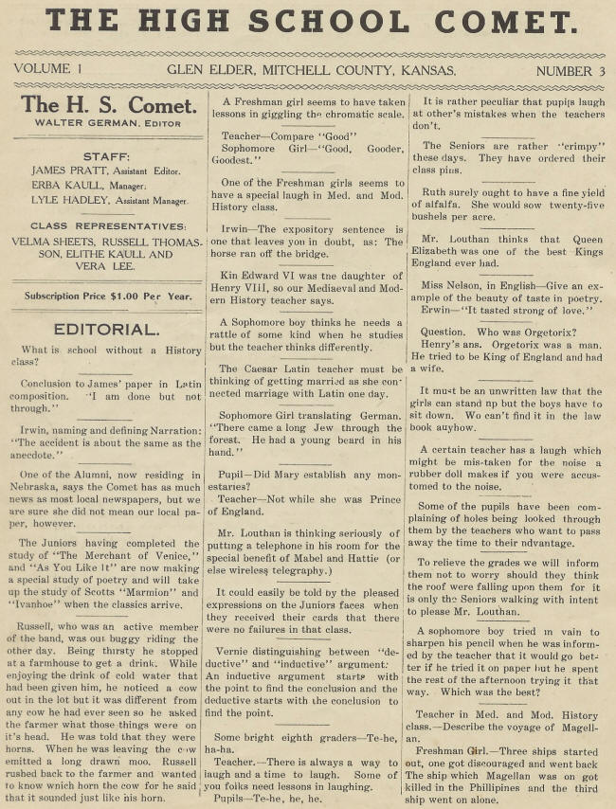

The following poem, a humorous piece, thematically focusing on businesses in Glen Elder in 1913, was written by 2 of Glen Elder High's students. E.K. is probably either Erba or Elithe Kaull, who are named with other paper staff. E.C. might have been either Elsie Cooper or Earl Cowman--two students whose names can be gleaned from a school play program contained in the issue.
The ads to the left of the poem represent the robust business climate in Glen Elder 93 years ago as well as providing business names.
Now, 93 years later, the poem, for its readers, perhaps gives life again to a time long past, one that only our parents and grandparents knew so well. Something to think about as one walks or drives the streets of Glen Elder, today.
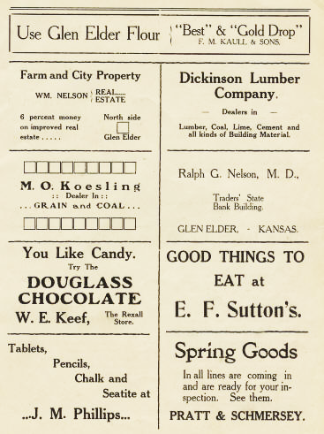 | A LITTLE BOOST  By E. K. and E. C.  In Glen Elder, our dear home town  We hail the merchants with renown  And to show our appreciation  We have written this oration.  Have you surplus moqey down to plank?  Put it in the Traders' State Bank;  But if you wish dry goods or Jerseys,  Just step in to Rratt & Sehmersey's.  If Douglass Chocolates she'd desire,  Go to Keef's, he will supply 'er;  If . you wish Pick wick groceries fine  Sutton has them along that line.  Do you need any school supplies?  Trueblood has them, also Diamond Dyes;  Outhwaite boosts for the Glen High School,  And to boost for him is our rule.  Have you noticed the 'High School lads  Butler sold then the latest fads.  You get good dry goods there you bet!  Where did you say? H. F. Vallette.  If bones or muscles are out of place,  Speak to Dr. Eustace, right to his face.  To get good prices is not hard  At the Glen Elder Lumber Yard.  Should you desire a fine new home,  Call Wm. Nelson over the phone.  For boots and shoes we have already found  An ideal place at E. F. Pound's.  If the housewife desires good buns  Get Geld Drop flour from Kaull & Sons.  M. O. Koesling is dealer in grain,  T e pa:troni_e .him you can't refrain.  Dr. Nelson, physician and surgeon,  Will come at your call without any urgin’  Cavender is the Jewelryman,  We patronize him and you can.  J. M. Phillips sells good things to eat,  In no other town can he be beat.  The Dickinson Lumber Company hath  Coal, Lime, Cement and Lath.  Novels, history and fiction. galore,  Get them at Suttons noted Book Store.  To get your clothes all cleaned and pressed,  Boller's Suitatorium is the best.  Did you say you wanted a plumber?  We recommend Walker, he's a hummer.

