Glen Elder, KS -- Heritage & History
~ Memoir Lane ~

A Child's Life, 1950's Glen Elder
-- Jim Humes

I was known by all my friends as Jimmy in my childhood and have continued to use either Jim or Jimmy instead of James.

I attended grade school in Glen Elder 1951-1957 and they are some of the happiest memories of my life.

My adopted mother and father, Blanch and Ed Humes, ran the “County Poor Farm,” located a few miles east of Glen Elder, for a number of years, before moving to town where my dad was the night watchman. Wouldn’t it be wonderful if that was all the security needed today?

My best friend, Gary Sanders, and a number of other boys, and sometimes a girl or two, spent many hours in the spring and summer on the creek banks behind the Humes home. We would build forts from driftwood and play cowboys and Indians for hours.

No television meant we had to use our imagination to be like the cowboys we heard on the radio or the movies that were shown for free on Saturday nights on the outdoor screen.
Although I said no television there were in fact two that I remember. One was set up in a storefront window on the town square and played, most evenings, for our enjoyment and advertisement. Perry Como, Lonesome George Goble and the occasional western movie starring Hop-along Cassidy, Lash Larue and the Duke, John Wayne would be playing. The other television belonged to the editor of the Glen Elder newspaper, Mr. Betz. His son, Carl, was also one of our friends who played with me during nighttime evenings square’s park. His dad would let some of us take turns watching the Walt Disney show on Friday evenings.

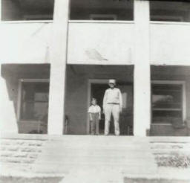
During the season we had high school baseball tournaments played in the all-purpose field behind the grade school. My friends and I would stay on the lookout for cracked bats (no aluminum ones then.) The teams almost always let us have the cracked ones and we would nail and tape them for use in our sand lot “bat-the-can” games.

Kansas’ snows, as I remember, were bad in the 1950’s. The one I remember most blew in, blizzard-style, while school was in session -- so quickly my dad couldn’t get into town to pick me up. I ended up staying overnight and the next day with my teacher, Ms. Lillian Morris. Dad finally made it to the city limits driving our old, steel lugged tractor. I was able to walk over the fences on the drifts to reach him.

In later snows, after we moved to town, we kids would talk about sledding down “dead-man’s hill.” Dead-man’s hill. That was that steep hill north of the First Christian church.

We were still living on the farm during the flood of 1951. The Solomon River got out of its banks and covered miles with dirty brown water. I fished off of the front porch with a stick (see photo at left), string and bent pin. There was much worry about water-borne diseases and our doctor (Dr. Hugh Hope) brought fresh drinking water to the farm via boat and then took me with him to the high ground of Hunter, Kansas. I do not remember how long the floodwaters lasted, but I do remember everyone having to drink quinine water to guard our health. After the flood my dad and some other men spent days cleaning the mud out of everything.

I would love to hear from some of my old grade school friends from those years by e-mail or snail mail. :>) Contributed by Jim Humes / 901 Canary Lane Enid, OK ► E-mail Jim

Glen Elder Cub Scouts, 1955 --- courtesy of Jim Humes
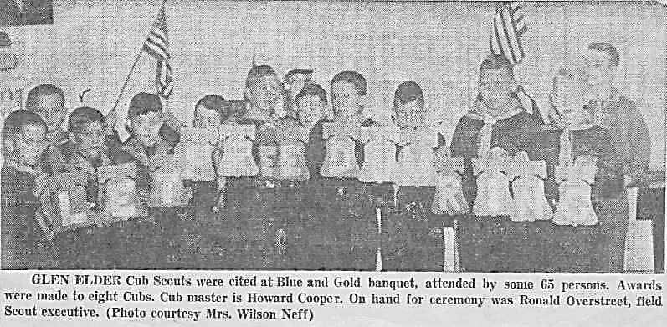
Can you identify any of the scouts? If so, thank you for E-mailing Us

